Title of Your Abstract Here
Jane Doe¹, John Doe², Maggie Smith¹, ¹Institution, City, Country, ²Institution, City, Country (list of authors)

Background, Motivation and Objective
Your text explaining what has been done previously and why this work is of importance.

Statement of Contribution/Methods
Description of equipment, methods used.

Results/Discussion
Presentation of the results obtained and discussion of the results.

Text may be completed with a clearly readable image if needed to better describe the work. (Example image)
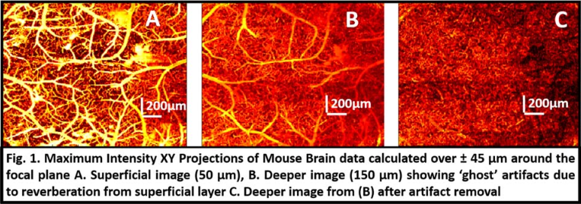
Recommendation:
Abstract without image: Text should be less than 2500 characters excluding spaces, title, author names, and affiliations.
Abstract with an image: Text with an image should be less than 2000 characters excluding spaces, title, author names, and affiliations.

